C# Programming Tutorial *with Alien Invaders!*

Greetings! Over the course of this project, you will learn to program in C#, which is one of the most popular programming languages used by professionals around the world today.

While you learn, you will be writing a video game sort of like the old “Space Invaders” game, which I’m calling “Alien Invaders”. Along the way, you will learn about many programming concepts and ideas that you will use as you write the game. You will also learn to use Microsoft’s Visual Studio programming tools.

The project is divided up into small-ish “assignments”. In each one you’ll make some progress on the Alien Invaders game, and learn something in the process. Each assignment will include a testing phase (because computer programmers should always test their code as they go), and you should not proceed to the next assignment until you are able to pass the test phase of the current one.

If you have any problems or questions, or if you can’t get the test to work properly, or if anything seems confusing or you don’t understand something, please contact me!

I hope you enjoy these assignments as much as I enjoy writing them!

The first thing you’ll need to do is download and install a version of Microsoft’s Visual Studio (if you haven’t already done that). If you don’t want to spend a lot of money (or any money), I recommend you get the current “Community Edition”, which you can find at [www.microsoft.com/visualstudio](http://www.microsoft.com/visualstudio). It’s free. At the time of this writing, the latest version is called “Community 2015”. That’s what I’ll be using, and all the screenshots and user-interface descriptions will be from that.

Once you get Visual Studio installed, we can get started…

# Assignment #1 – Set Up the AlienInvaders Project

In this assignment, you will create a new Visual Studio C# project, set up a few things, and test it.

**Important**: Each assignment in this series will pick up where the last one left off. That means each one will start off assuming you completed the last one and didn’t change anything. If you want to experiment and try things, that’s great, but always do that in a different project, or you’ll be lost when you get to the next assignment and things are different from what they’re supposed to be. If you do get hopelessly lost, let me know and I’ll send you whatever completed assignment you need to get going on the next one.

## Step 1 – Create the project

1. Click on *File* -> *New* -> *Project…*
2. Select *Windows Forms Application*. Make sure *Visual C#* is selected on the left.
3. For the name, enter “AlienInvaders”.
4. Click *Ok*.

This will create a new “Windows Forms” project. Windows Forms is the part of something called “.NET” (pronounced “dot-net”), which is just a bunch of stuff that Microsoft provides as part of Windows that gives programmers the ability to do different things. There is a *lot* of stuff in .NET, and we’ll just be touching the tip of the iceberg in this project.

At this point, you should see something like this:

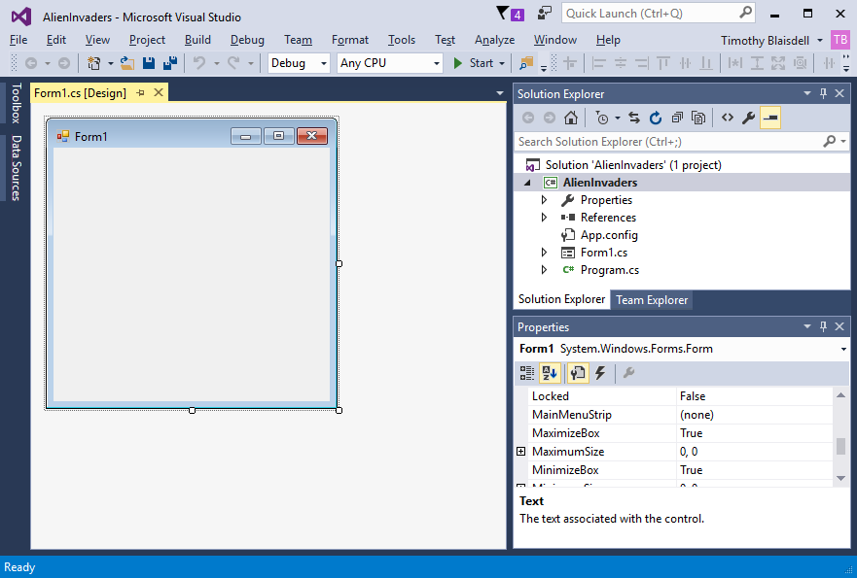

The colors may be different for you, and of course you won’t see my name at the top, but essentially, you’ve got a window called “Form1” with nothing on it. Your project has two main source files (that is, files with C# source code in them) called “Form1.cs” and “Program.cs”.

## Step 2 – Set up a few things

1. Change the title of the window to “Alien Invaders”:   
   Click on the empty window on the left called “Form1” (to select it) and look over at the Properties list on the right. Scroll down through the Properties list until you find the property called “Text”. It should be set to “Form1”, like this:



Change the Text property value from “Form1” to “Alien Invaders” (capitalized, with a space between the words) and press Enter. You will see that the title of the empty window changes to “Alien Invaders”, like this:



1. Change the window’s size:  
   Now look for the “Size” property in the Properties list. It will probably be set to “300, 300”. Change the size to “600, 600” and press Enter. You will see the window change size. You’ve changed the window’s size from 300 by 300 pixels to 600 by 600. That will be the default size of the game’s window.
2. Change the window’s name:  
   Look through the Properties list again and find the “(Name)” property. It’s up toward the top of the list. This should be set to “Form1”. Change it to “AlienInvadersForm”. Notice that each word is capitalized and there are no spaces.



1. Change the C# source file’s name to match the name of the window:  
   Now go to the “Solution Explorer” (which should be visible on the screen – if it’s not you can bring it up by clicking *View* -> *Solution Explorer*). In the Solution Explorer, you should see a file called “Form1.cs”. Right-click on this file and select *Rename*. Then type “AlienInvadersForm”. This will rename the source code file to be the same as the name of the form defined in that file.  
     
   At this point, your Solution Explorer should look like this:

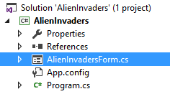

## Step 3 – Test the program

Every programmer should always test his code now and then as he’s working. Don’t expect to do a ton of work on a program and have it work perfectly at the very end. Test your programs as you go along, to make sure each change you make works as you expect.

To test the AlienInvaders program as it is now, just click on the Start button at the top of the screen:



This will compile and build the program and run it.

If you see anything about using *script diagnostics*, just press *Cancel*.

You should see an empty window come up with the title “Alien Invaders”. You should be able to resize it, move it around, maximize it, minimize it, etc. Just like any other program you might use. It should look like this:

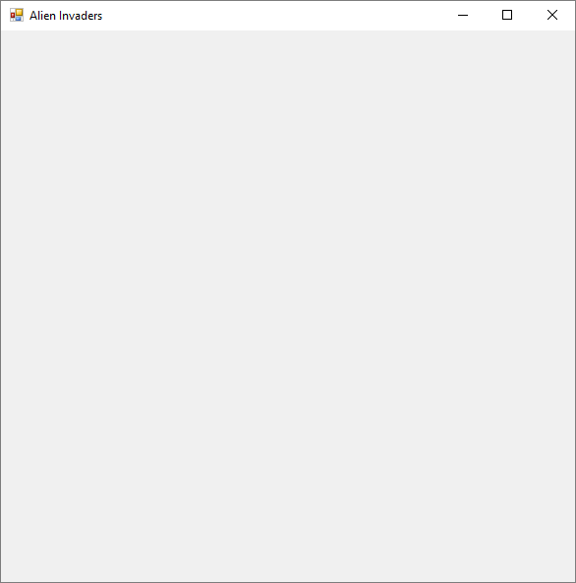

If you see that, you’re done with this assignment. Congratulations!

Be sure to click *File* -> *Save All* to save everything.

Things to think about:

1. Get used to using the different sub-windows in Visual Studio. For example, in this assignment, you used the following:

* The “designer” window that lets you see what you’re window will look like when you run the program (that’s the empty window on the left)
* The “Properties” window that lets you modify properties of different objects (like the size, name, text, colors, etc.)
* The “Solution Explorer” window that lets you see all the files and stuff in your projects, and all the projects in your “solution”. In Visual Studio, a “solution” is just a group of projects. In this case our solution is called “AlienInvaders”, and it contains just one project, which is also called “AlienInvaders”.

1. Throughout this project, we will be using something called “CamelCase” a lot. We used it when we named our window “AlienInvadersForm”, and when we named our source file “AlienInvadersForm.cs”. Also, we named our solution and our project “AlienInvaders”. CamelCase is what programmers call it when you name things by stringing all the words together and capitalizing each word. CamelCaseLooksLikeThis. It’s called CamelCase because the capital letters pop up like a camel’s humps. It’s used because names of things in code cannot have spaces, so the capital letters make them easier to read.

Itsalittlehardtoreadthis

ButItsEasierToReadThis

You don’t have to use CamelCase, but it’s a helpful habit to adopt, and virtually all programmers use it when naming things in their code.